Experiment description

The goal of the experiment is to establish how to model individual differences in color perception (observer metamerism) across a large population. To achieve this goal, you will be tasked with evaluating color patches shown on displays using different emission technologies, such as OLED and LCD. **The patches are predicted to match across all displays based on existing color models but might appear mismatched to you because of your individual color sensitivities.**

When presented with two patches, you will select how different the patches appear to you, ranging from a perfect match (score of 5) to an unacceptable match (score of 1). Rate the color matches as you would in your everyday work experience, taking as much time as you need and using any criterion or technique you’d normally apply to color evaluation.

Once you’ve chosen the color match rating, input your choice using the provided controller, following the score distribution and interpretation shown below. A sound will play out, indicating your choice, followed by a 5 second adaptation period. After the adaptation, another two patches will light up, showing either a different color or the same color on a different pair of displays, prompting another selection. Once the experiment is finished, a pre-recorded voice will announce “experiment complete.”

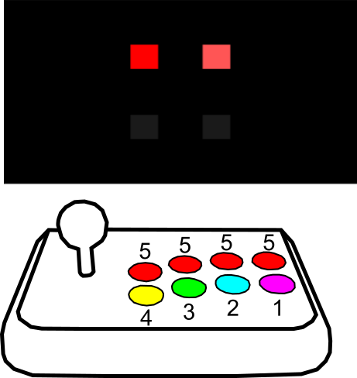

You can wear prescription glasses if you’d also normally wear them during critical color evaluations. You can take a break at any point during the experiment if you feel like you need one.